COUNTY COUNCIL OF PRINCE GEORGE'S COUNTY, MARYLAND
SITTING AS THE DISTRICT COUNCIL
2026 Legislative Session

Bill No. | CB-070-2026
Chapter No.
Proposed and Presented by |  |  |  |  | Council Members Dernoga and Blegay
Introduced by
Co-Sponsors
Date of Introduction

ZONING BILL
AN ORDINANCE concerning
Use Regulations and Dimensional Standards – Places of Worship
For the purpose of amending the definition of a place of worship; amending the intensity and dimensional standards in certain residential zones to allow such standards to be modified when applied to a place of worship; and amending use regulations to provide modified design standards for places of worship on assemblages of twenty-five acres or more to provide, subject to the approval of a detailed site plan.
BY repealing and reenacting with amendments:
Sections 27-2500, 27-4202 and 27-5102,
The Zoning Ordinance of Prince George's County, Maryland,
being also
SUBTITLE 27. ZONING.
The Prince George's County Code
(2023 Edition; 2025 Supplement).
SECTION 1. BE IT ENACTED by the County Council of Prince George's County, Maryland, sitting as the District Council for that part of the Maryland-Washington Regional District in Prince George's County, Maryland, that Sections 27-2500, 27-4202 and 27-5102 of the Zoning Ordinance of Prince George's County, Maryland, being also Subtitle 27 of the Prince George's County Code, be and the same are hereby repealed and reenacted with the following amendments:
SUBTITLE 27. ZONING.
PART 27-2. INTERPRETATION AND DEFINITIONS
Sec. 27-2500. Definitions
* * * * * * * * *
Place of worship
A building, structure, or area of land where people regularly assemble to conduct religious worship, ceremonies, rituals, and related education. Places of worship include chapels, churches, mosques, shrines, synagogues, tabernacles, temples, and other similar religious places of assembly. Places of worship may contain administrative offices, an assembly hall, a banquet facility (including a shared commercial kitchen), a cafeteria for worshipers and visitors, indoor recreational facilities, or similar uses that support the religious function.
* * * * * * * * *
PART 27-4. ZONES AND ZONE REGULATIONS.
SECTION 27-4200. BASE ZONES.
Sec. 27-4202. Residential Base Zones.
* * * * * * * * *
(b) Residential Estate (RE) Zone
* * * * * * * * *
(2) Intensity and Dimensional Standards
(2) Intensity and Dimensional Standards
Standard(1) | Agricultural Uses | Single-Family Detached Dwelling | Other Uses(5)
Density, max. (du/ac of net lot area) | No requirement | 1.08 | No requirement
Net lot area, min (sf). | 87,120 or 2 acres | 40,000 | 40,000
❶ Lot width, min. (ft) | 50 | 120(4) | 50
Lot frontage (width) at front street line, min. (ft) | 40 | 70 | 40
Lot coverage, max. (% of net lot area) | 20 | 20 | 60
❷ Front yard depth, min. (ft) | 25 | 25 | 25
❸ Side yard depth, min. (ft) (2) | 17 | 17 | 17
❹ Rear yard depth , min. (ft) | 25 | 25 | 25
❺ Principal structure height, max.(ft) | 35 | 35 | 35
Accessory structure height, max.(ft) (3) | 15 | 15 | 15
NOTES: du/ac = dwelling units per acre; sf = square feet; ft = feet
- See measurement rules and allowed exceptions in Section 27-2200, Measurement and Exceptions of Intensity and Dimensional Standards.
- On corner lot, min. side yard depth alongside street = 25 ft.❻
- May be increased for certain purposes by approval of a special exception pursuant to Section 27-3604, Special Exception, and may be increased to forty (40) feet with approval of a Special Exception, if the building is used for agricultural purposes and is erected on property (used for agriculture) containing at least five (5) acres.
- If the lot is served by an individual well or sewerage system, the min. width shall be 150 ft.
- Intensity and Dimensional Standards for a Place of Worship, Cultural Facility, or Convent or Monastery may be modified in accordance with Section 27-5102(d)(2)(C)(vii), Requirements for Permitted Uses.
Single-Family Detached Dwellings and Other Uses

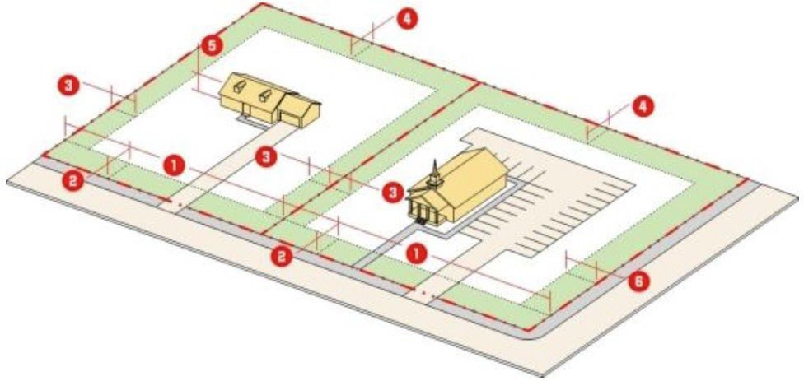

(3) Reference to Other Standards
* * * * * * * * *
Sec. 27-5102. Requirements for Permitted Principal Uses | Sec. 27-6700 Exterior Lighting | Sec. 27-61500 Signage
Sec. 27-5200 Accessory Uses and Structures | Sec. 27-6800 Environmental Protection and Noise Controls | Sec. 27-61600 Green Building Standards
Sec. 27-5300 Temporary Uses and Structures | Sec. 27-6900 Multifamily, Townhouse, and Three-Family Form and Design Standards | PART 27-2 Interpretation and  Definitions
Sec. 27-6200 Roadway Access, Mobility, and Circulation | Sec. 27-61000 Nonresidential and Mixed-Use Form and Design Standards | PART 27-7 Nonconforming  Buildings, Structures, Uses, Lots, and Signs

(c) Residential, Rural (RR) Zone
* * * * * * * * *
(2) Intensity and Dimensional Standards
Standard(1) | Single-Family  Detached Dwelling | Other Uses (5)
Density, max (du/ac of net lot area) | 2.17 | No requirement
Net lot area, min. (sf) | 20,000 | 20,000
❶ Lot width, min. (ft) | 80(4) | 100
Lot frontage (width) at front street line, min. (ft) | 70 | 70
Lot coverage, max. (% of net lot area) | 25 | 60
❷ Front yard depth, min. (ft) | 25 | 25
❸ Side yard depth, min. (ft) (2) | 8 | 8
❹ Rear yard depth, min. (ft) | 20 | 20
❺ Principal structure height, max. (ft) | 40 | 40
Accessory structure height, max. (ft) (3) | 15 | 15
NOTES: du/ac = dwelling units per acre; sf = square feet; ft = feet
- See measurement rules and allowed exceptions in Section 27-2200, Measurement and Exceptions of Intensity and Dimensional Standards.
- On corner lot, min. side yard depth alongside street = 25 ft.❻
- May be increased for certain purposes by approval of a special exception pursuant to Section 27-3604, Special Exception, and may be increased to forty (40) feet with approval of a Special Exception, if the building is used for agricultural purposes and is erected on property (used for agriculture) containing at least five (5) acres.
- Minimum 100 ft if the lot is not served by a public or other approved water supply system.
(5) Intensity and Dimensional Standards for a Place of Worship, Cultural Facility, or Convent or Monastery may be modified in accordance with Section 27-5102(d)(2)(C)(vii), Requirements for Permitted Uses
Single-Family Detached Dwellings and Other Uses
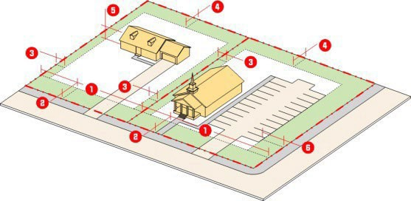

(3) Reference to Other Standards
* * * * * * * * *
Sec. 27-5102. Requirements for Permitted Principal Uses | Sec. 27-6700 Exterior Lighting | Sec. 27-61500 Signage
Sec. 27-5200 Accessory Uses and Structures | Sec. 27-6800 Environmental Protection and Noise Controls | Sec. 27-61600 Green Building Standards
Sec. 27-5300 Temporary Uses and Structures | Sec. 27-6900 Multifamily, Townhouse, and Three-Family Form and Design Standards | PART 27-2 Interpretation and  Definitions
Sec. 27-6200 Roadway Access, Mobility, and Circulation | Sec. 27-61000 Nonresidential and Mixed-Use Form and Design Standards | PART 27-7 Nonconforming  Buildings, Structures, Uses, Lots, and Signs
* * * * * * * * *
(d) Residential, Single-Family-95 (RSF-95) Zone
* * * * * * * * *
(2) Intensity and Dimensional Standards
Standard(1) | Single-Family  Detached Dwelling | Other Uses(5)
Density, max (du/ac of net lot area) | 4.58 | No requirement
Net lot area, min. (sf) | 9,500 | 9,500
❶ Lot width, min. (ft) | 75 | 75
Lot frontage (width) at front street line, min. (ft) | 50 (4) | 60
Lot coverage, max. (% of net lot area) | 30 | 60
❷ Front yard depth, min. (ft) | 25 | 25
❸ Side yard depth, min. (ft) (2) | 8 | 8
❹ Rear yard depth, min. (ft) | 20 | 20
❺ Principal structure height, max. (ft) | 40 | 40
Accessory structure height, max. (ft) (3) | 15 | 15
NOTES: du/ac = dwelling units per acre; sf = square feet; ft = feet
- See measurement rules and allowed exceptions in Section 27-2200, Measurement and Exceptions of Intensity and Dimensional Standards.
- On corner lot, min. side yard depth alongside street = 25 ft.❻
- May be increased for certain purposes by approval of a special exception pursuant to Section 27-3604, Special Exception.
- If the lot is located on a cul-de-sac, the minimum width may be reduced to forty-five (45) feet.
(5) Intensity and Dimensional Standards for a Place of Worship, Cultural Facility, or Convent or Monastery may be modified in accordance with Section 27-5102(d)(2)(C)(vii), Requirements for Permitted Uses
Single-Family Detached Dwellings and Other Uses

(3) Reference to Other Standards
* * * * * * * * *
Sec. 27-5102. Requirements for Permitted Principal Uses | Sec. 27-6700 Exterior Lighting | Sec. 27-61500 Signage
Sec. 27-5200 Accessory Uses and Structures | Sec. 27-6800 Environmental Protection and Noise Controls | Sec. 27-61600 Green Building Standards
Sec. 27-5300 Temporary Uses and Structures | Sec. 27-6900 Multifamily, Townhouse, and Three-Family Form and Design Standards | PART 27-2 Interpretation and  Definitions
Sec. 27-6200 Roadway Access, Mobility, and Circulation | Sec. 27-61000 Nonresidential and Mixed-Use Form and Design Standards | PART 27-7 Nonconforming  Buildings, Structures, Uses, Lots, and Signs
* * * * * * * * *
PART 27-5. USE REGULATIONS
SECTION 27-5100. PRINCIPAL USES
Sec.27-5102. Requirements for Permitted Principal Uses
* * * * * * * * *
(d) Public, Civic, and Institutional Uses
* * * * * * * * *
(2) Community Service Uses
* * * * * * * * *
(C) Place of Worship
(i) Ingress and egress shall be located so as to direct traffic away from streets that are internal to a residential subdivision, where possible.
* * * * * * * * *
(vi) The maximum allowable lot coverage for the zone in which the use is proposed shall not be increased, unless the place of worship development meets the requirements set forth in subsection (vii).
(vii) Notwithstanding any other provision to the contrary in this Ordinance, a place of worship, when located on an assemblage of property containing a minimum of twenty-five (25) acres, and any cultural facility or convent or monastery located on the same property, may be approved with modified design standards, subject to the approval of a detailed site plan in accordance with Section 27-3605(d), Detailed Site Plan Procedure, and subject to the following:
(aa) (I) The maximum allowable height of the place of worship (e.g, church, mosque, temple, mandir) may be increased above the maximum standard permitted in the base zone, provided that, for each one (1) foot increase in height, above the base zone requirement, each yard setback standard shall be increased by one (1) foot.
(II) The maximum allowable height of any other principal use (e.g. cultural facility or convent or monastery) and any accessory structure or use thereto, located on the same property may be increased above the maximum standard permitted in the base zone not to exceed sixty (60) feet, provided that, for each one (1) foot increase in height, above the base zone requirement, each yard setback standard shall be increased by one (1) foot.
(bb) The maximum lot coverage for the property may be increased by five percent (5%), provided that a Type C Buffer yard is provided on all property lines shared with residential uses, and that the increase in the maximum lot coverage will be offset by enhanced stormwater management, flood control, use of solar or geothermal power, off-site tree mitigation, or similar environmental benefits.
(cc) Notwithstanding any other provision of this Ordinance to the contrary, a place of worship use, and any cultural facility or convent or monastery located on the same property, or any structure, accessory structure, or use are subject to the following modifications of the Part 27-6 Development Design Standards:
- The property shall be limited to two (2) two-way driveway or two (2) pairs of one-way driveways for each arterial, major collector, or collector street frontage.
- The proposed uses shall not be subject to any maximum parking requirement. The provisions of Section 27-6306(d), Maximum Number of Off-Street Parking Spaces, shall not apply and the proposed uses shall not be subject to any maximum parking requirement.
- Exterior lighting on the property shall be permitted in accordance with Section 27-6706, General Standards for Exterior Lighting, except that the hours of operation may be extended to a 24-hour cycle, provided that no lighting fixtures operating after 11:00 PM result in the maximum illumination level at an adjacent residential lot line to exceed 0.2 foot-candles. Further, there shall be no maximum height for exterior lighting when mounted on a building with a place of worship use and any associated cultural facility, convent or monastery, or a permitted accessory structure or use, provided that such lighting does not create unsafe glare on street rights-of-way, but all exterior lighting placed on poles shall remain limited to a maximum height of sixteen (16) feet.
- The provisions of Section 27-61002, Nonresidential and Mixed-Use Form and Design Standards, shall not apply to any of the proposed uses.
- The following provisions of Section 27-61203, Neighborhood Compatibility Standards, shall not apply to any of the proposed uses: Section 27-61203(a)(1), Building Height and Setbacks, Section 27-61203(b), Building Orientation, Section 27-61203(c), Building Design, Section 27-61203(d), Building Materials, Section 27-61203(e), Multi-Building Placement, and Section 27-61203(f), Off Street Parking, and Section 27-61203(g), Other Site Features. A Type C Buffer yard shall be provided on all property lines shared with residential uses.
- Institutional signs shall be permitted on the property in accordance with Section 27-61506, Standards for Special Purpose Signs, except that the maximum signage area per each sign shall be increased to 200 square feet, and the maximum height per sign shall be fifteen (15) feet above finished grade at the base of the sign, provided that, for each one (1) foot increase in height above the standard requirement, the sign minimum setback shall be increased by one (1) foot. The number of permitted signs shall not exceed two (2) per street the property fronts on, regardless of whether the sign faces said street. The signs shall be monument signs and may be front lit.
(ee) Any accessory structure or use to a place of worship or cultural facility located on the same property, shall be exempt from Section 27-5202(b), Relationship to Principal Use or Structure, and Section 27-5202(c), Location of Accessory Uses and Structures.
* * * * * * * * *
SECTION 2. BE IT FURTHER ENACTED that this Ordinance shall take effect upon its adoption.
Adopted this day of , 2026.
COUNTY COUNCIL OF PRINCE GEORGE’S
COUNTY, MARYLAND, SITTING AS THE
DISTRICT COUNCIL FOR THAT PART OF
THE MARYLAND-WASHINGTON REGIONAL
DISTRICT IN PRINCE GEORGE’S COUNTY,
MARYLAND

BY: _________________________________
Krystal Oriadha
Chair
ATTEST:

______________________________
Donna J. Brown
Clerk of the Council

KEY:
Underscoring indicates language added to existing law.
[Brackets] indicate language deleted from existing law.
Asterisks *** indicate intervening existing Code provisions that remain unchanged.

* * * * * * * * *

